* 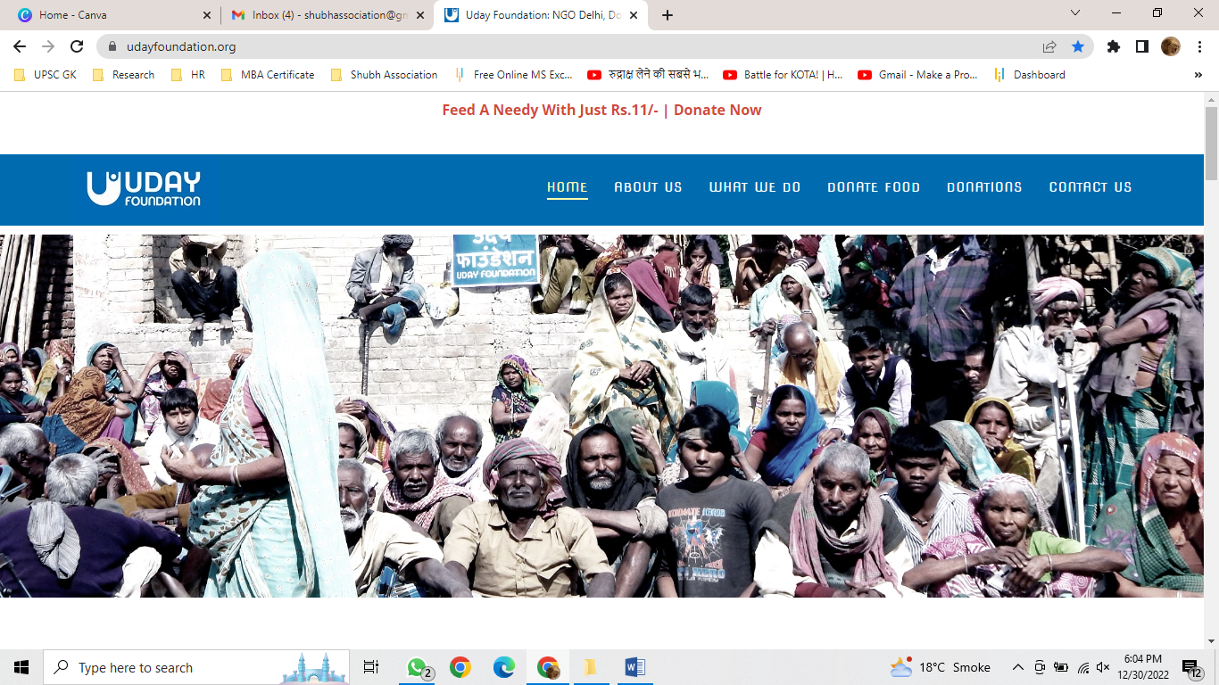Instead of what we do – give an option of fund raisers
* Rest things will be same

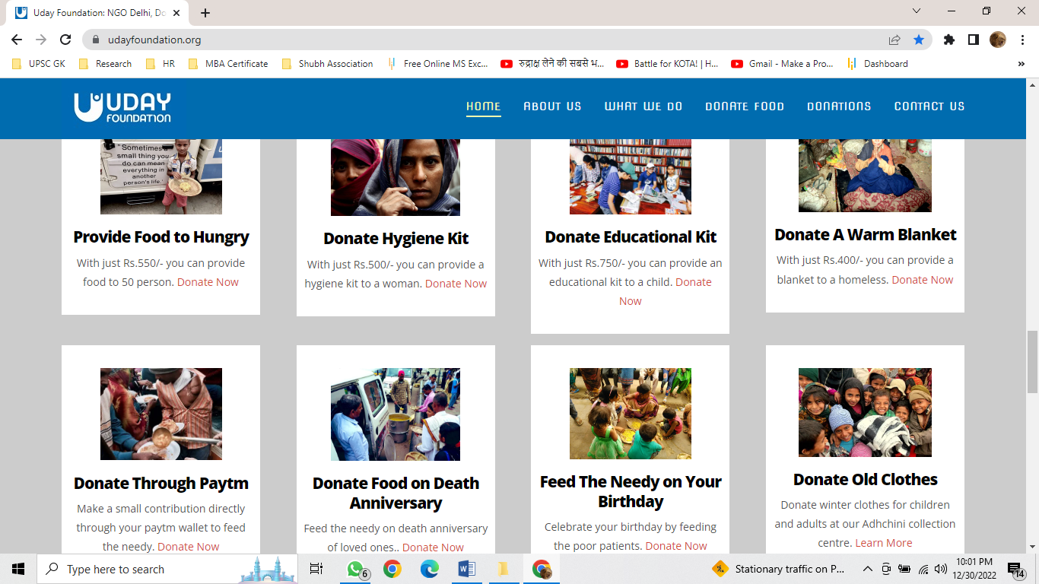

2nd interference , which comes after scrolling

3rd interference which will show in website after scrolling

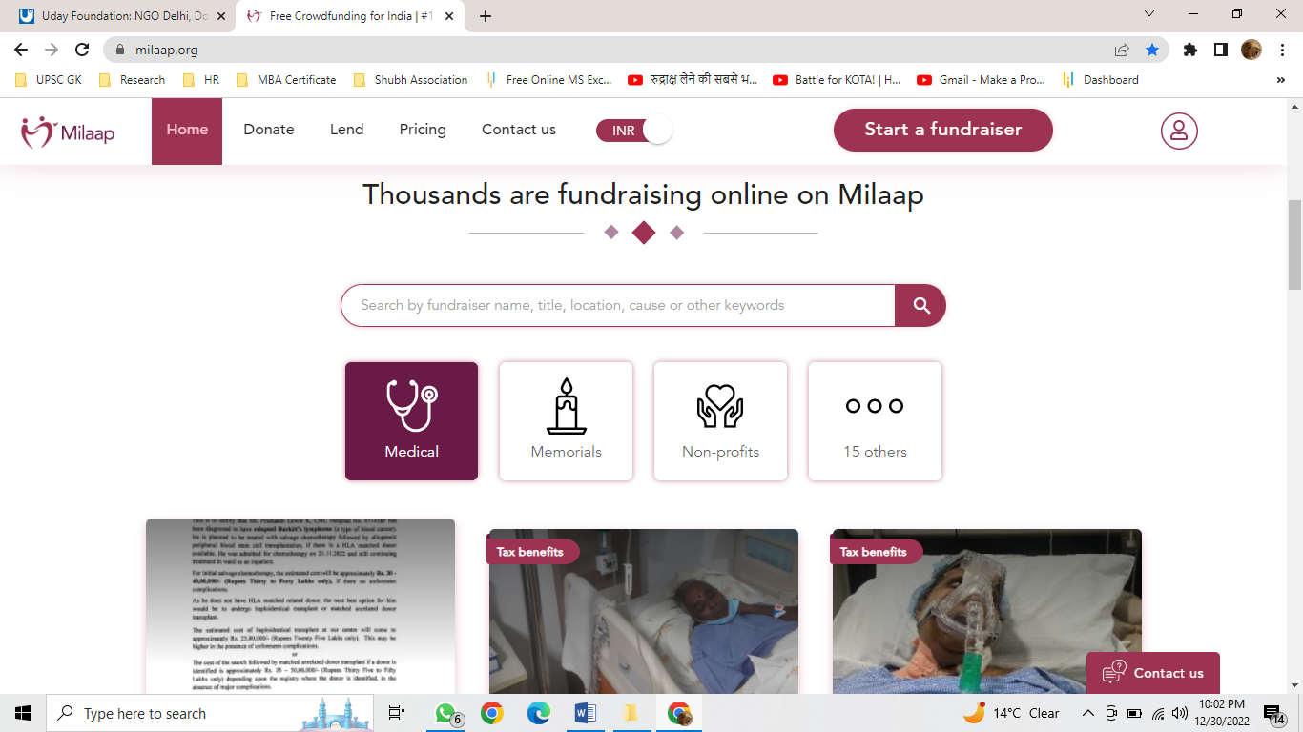

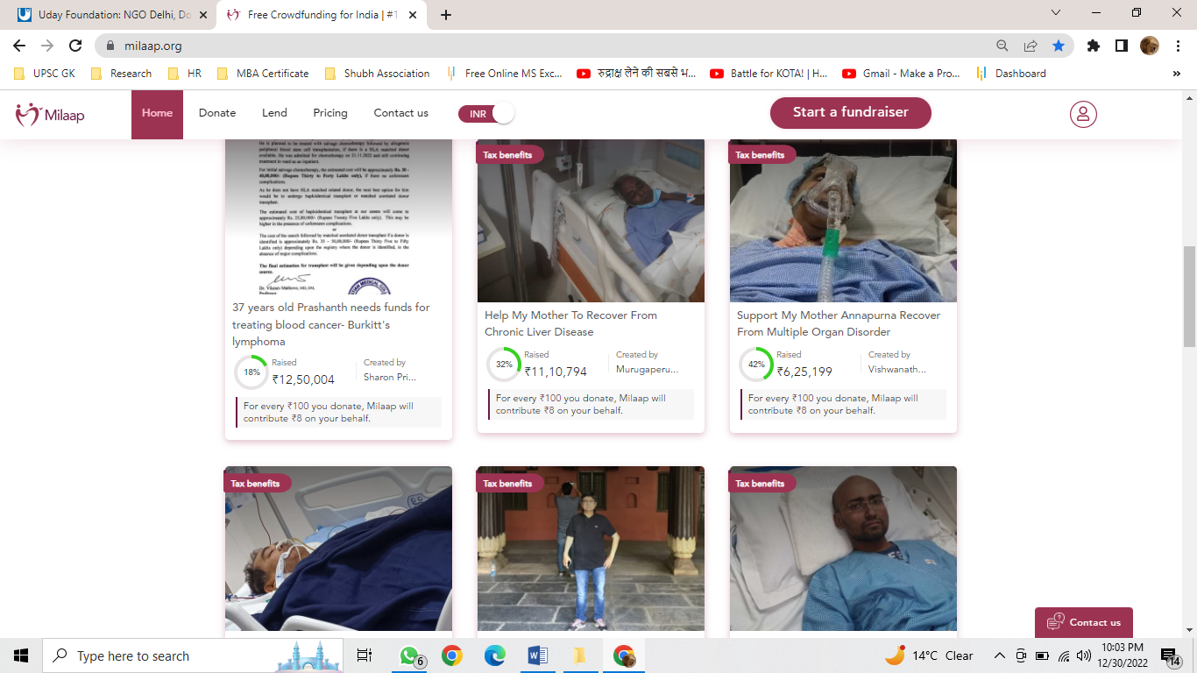

4th and last interference ---- our all pages link will be visible at here

